

MODULE 11.2. ASSIGNMENT: JAVASCRIPT EXERCISE, PART 3

ELVIA GISELLA ADAIR
STUDENT

CHRISTINE MAZHATA
TEACHER

MARCH 15, 2026
MODULE 11.2. ASSIGNMENT JAVASCRIPT EXERCISE, PART 3
- Main
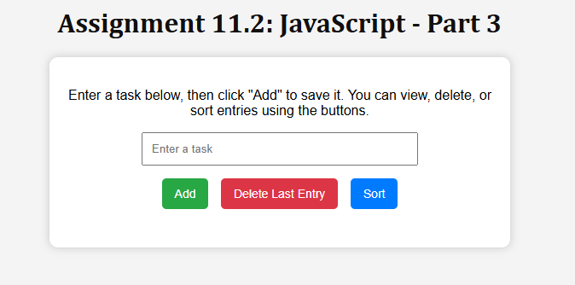

- Create a to do list

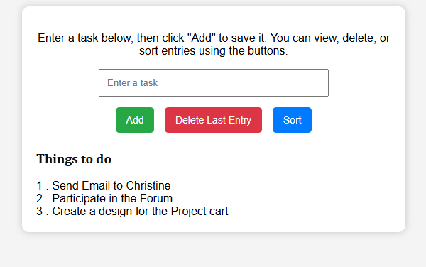
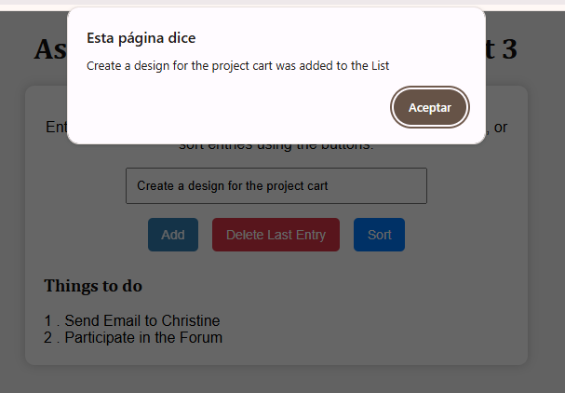

- Delete the last Entry

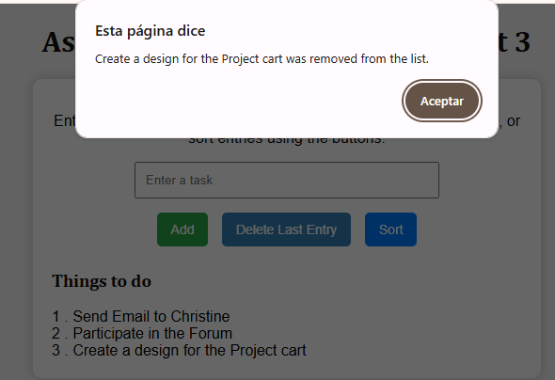

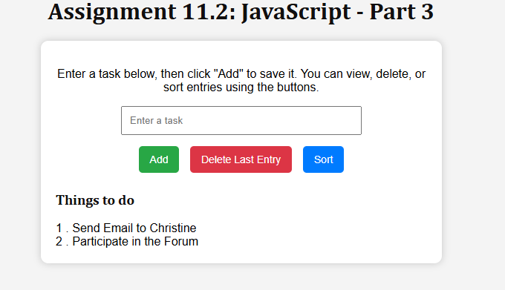
- Sort
